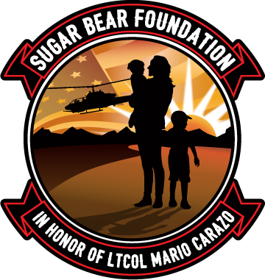

Sugar Bear Foundation Registry Application
In order to routinely update you with resources, opportunities and event information for Gold Star spouses and their children, please complete and email the following to: Admin@TheSugarBearFoundation.org
☐ Sugar Bear Foundation Registry Application (this form)
☐ Copy of the DD1300 or other proof that you are receiving benefits due to your spouse’s
death from military service (PDF Files or legible photos are acceptable)
☐Subscribe to our Newsletter – https://Subscribe.TheSugarBearFoundation.org
☐Review and Apply for our Sugar Bear Foundation Programs and other Resources – https://Programs.TheSugarBearFoundation.org
Name: Click or tap here to enter text.
Home Address: Click or tap here to enter text.

Mailing Address: Click or tap here to enter text.

Phone Number: Click or tap here to enter text.
Email Address: Click or tap here to enter text.
Child/Children’s Names:
- Click or tap here to enter text.
- Click or tap here to enter text.
- Click or tap here to enter text.
Ages: Click or tap here to enter text.

Which of the following types of programs and services would interest your family? Please Check any and all that apply:
☐ Educational  ☐ Career  ☐ Financial | ☐ Internships  ☐ Career Mentoring  Other: Click or tap here to enter text.

If you have any questions, please feel free to send an email to: Admin@TheSugarBearFoundation.org

